Plot 1.

After analyzing 11.1M of Data related to HealthCare. I found some distribution of the population based on number of patients with Breast Cancer per year for 2010-2016 according “Data Platform” data set. See Figure 1. Figure 1, was created using Java as programing Language. I generated a tool to read the data.csv file and extract relevant information. The graph is based in the information extracted.

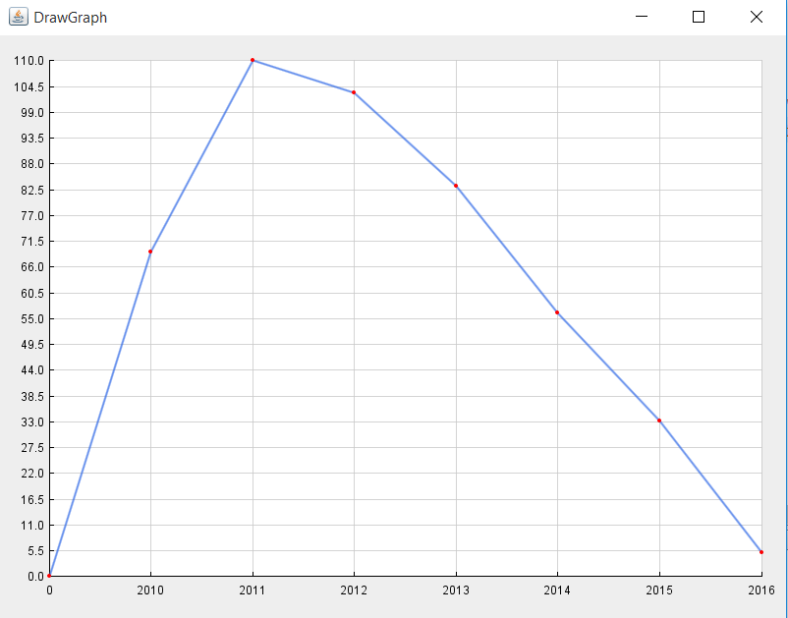

**Figure1.** Total of number of patients with breast cancer per year according to the Healthcare US census

**Figure1 Data**

**Year – Number of patients with Breast Cancer**

2010 --> 69

2011 --> 110

2012 --> 103

2013 --> 83

2014 --> 56

2015 --> 33

2016 --> 5

For more information check: <https://github.com/Danissa/DATAINCUBATOR/tree/master/DANISSA-DATA%20INCUBATOR>